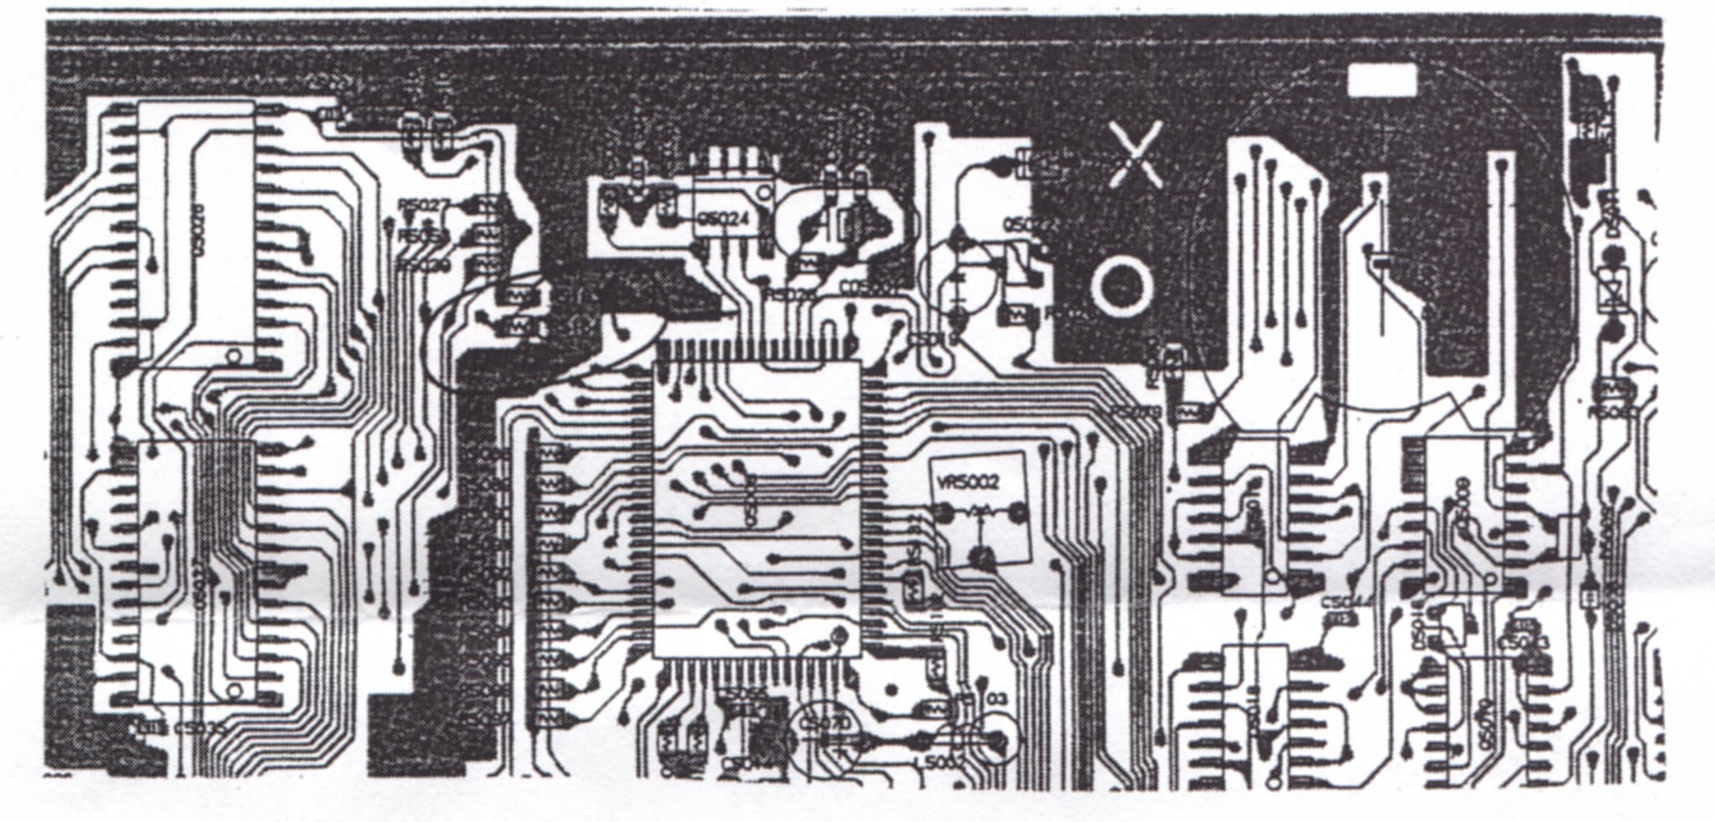

R5163 (move to this location)
R5164 (original location)

Move R5164 from above location to the R5163 location, which is the open pad right above it. See below.

1. Remove power from Unit.

2. Remove upper and lower cover.

3. On the Control Unit, you will need to move the resister from the R-5164 location to the open spot where R-5163 is not in place.

4. Reset the CPU by holding down the “SUB” + “29” + “ENT” buttons while you power on the radio.

5. Turn off the radio.

6. Hold down the Fast and Lock buttons while you power on the radio. Release the Fast and Lock buttons.

7. Press the “Fast” button and hold it down while you momentarily press the “ENT” button.

8. Rotate the “MEM/CH” knob to Menu 9-9.

9. Rotate the VFO to “GEN” .

10. Press the “ENT” button.

11. Modification is complete.

This modification will open the transmit from 1.500-29.999 MHz.

