
Permanent Magnet Electrodynamic Brakes Design Principles and Scaling Laws
Marc T. Thompson, Ph.D.
marctt@aol.com
President, Thompson Consulting  25 Commonwealth Road  Watertown, MA 02472 | Adjunct Professor of Electrical Engineering  Worcester Polytechnic Institute  Worcester, MA 01609

Abstract
Permanent magnet (PM) eddy current brakes are a simple and reliable alternative to mechanical, pneumatic or electromagnetic brakes in transportation applications. Results from a high speed rotating test fixture were used to develop a set of magnetic scaling laws for the sizing and cost analyses of brakes. Using these results, a full-scale brake was designed for a roller coaster application. Good agreement is found between the experimental results from the test fixture and analytical result based on electrodynamic theory.

Introduction
The research outlined in this paper addresses the design of permanent magnet eddy current braking devices that can be utilized in vehicles, elevators and moving machinery of all sorts. A scale-model fixture was used to test several different linear passive brakes based on neodymium-iron-boron (NdFeB) permanent magnets. Test results were used to generate a set of scaling laws for magnetic, cost, and mechanical scaling of the brakes. The results are applicable to size and cost scaling of magnetic brakes as well as other applications such as Maglev and permanent magnet motors. Using these results and scaling laws, a full-scale brake for a roller coaster application was designed.

Electrodynamic description of braking force
Consider a wire carrying DC current, traveling in the x direction with velocity v over an electrically conducting plate (Figure 1a). The wire is infinitely long in the y-direction. The wire creates a moving magnetic flux and induces currents in the plate and hence levitation and drag forces. The magnetic drag force acting on the wire in the -x direction is (Figure 1b) [1]:
$$f_{b} =F_{o}\frac{v_{\text{pk}}v}{v^{2}+v_{\text{pk}}^{2}}$$

(a) | 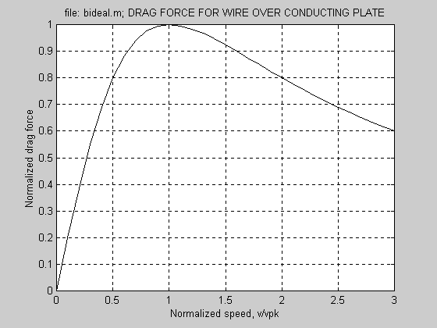  (b)

Figure 1. Current-carrying wire traveling over a stationary conducting plate
(a) Geometry. (b) Braking force vs. speed
Force F_{o} is the "image force," or the force that acts on the wire if there was an identical wire on the other side of the plate and the plate were removed. The velocity v_{pk} is the “drag peak” velocity and is given by:
$$v_{\text{pk}}=\frac{2}{\text{ms}T}$$
where σ and μ are the electrical conductivity and magnetic permeability of the plate and T is its thickness. The important functional dependencies of the magnetic drag force are :
- At low velocity, magnetic drag is linearly proportional to velocity.
- The drag force reaches a peak value at a finite velocity v_{pk}.
- Above the drag peak velocity, the drag force decreases as 1/v.
- The drag peak velocity is lower for a thicker plate.

A magnetic brake may be designed using permanent magnets, as shown in Figure 2. Permanent magnets and backiron create a closed magnetic circuit. The magnets have width w_{m} and pole pitch p. The conducting fin has thickness T and there is a relative velocity v between the magnet array and fin.
Figure 2. Double sided brake
Similar to a linear induction motor, the pole pitch p, track thickness T and velocity v all affect the magnetic forces. The key is to optimize the brake by varying the magnet pole pitch p and the fin thickness T in order to minimize the mass and cost of the permanent magnet material. The brake design requires optimizing these parameters as well as the airgap length and the aspect ratio of the permanent magnets.
In the limit of a very long pole pitch (i.e. p → ∞) the drag force profile approaches that of the wire over the flat plate, as shown previously. For finite wavelengths, the pole pitch comes into play as well. The results provide a compact solution for the magnetic braking force, reproduced in the equations below. Simplifying approximations are that the magnets are semi-infinite in the y direction and that magnetic field in the airgap is dominated by the first harmonic component, varying only in the x direction. The braking force is found by [2]:
$$\begin{aligned}f_{b}=F_{0}´\left\{−\text{Im}(P)\right\} \\ P=\frac{j(1−m^{2})\text{tan}(k_{z}T)}{2m−j(1+m^{2})\text{tan}(k_{z}T)} \\ m=\frac{−{\text{jk}}_{z}}{k} \\ k_{z}»\sqrt{j{\text{sm}}_{o}\text{vk}−k^{2}}\end{aligned}$$
Here, k is the wavenumber of the first harmonic of the airgap flux (= 2π/p), v is velocity, F_{o} is the image force, and all other parameters are derived. At low speeds, the braking force is proportional to velocity and may be simply approximated as:
$$f_{b}»\frac{1}{2}B_{g}^{2}s\text{ATv}$$
linearly proportional to fin velocity, electrical conductivity, and fin volume in the airgap.

Test fixture design and test results
The results given previously for braking force is an approximation, and hence it is desirable to verify this result with test results. A high speed rotating test facility was designed for this purpose.

Test fixture design
A test fixture was built to evaluate various brake geometries. The text fixture (Figure 3) is composed of a rotating disk driven by an adjustable speed DC motor. The 0.125" thick aluminum disk, which may be changed for different brake geometries, has a nominal diameter of 0.37 meters, and is designed to operate at speeds up to 2000 R.P.M., which corresponds to a linear peripheral speed of up to 40 meters/sec. The speed of the wheel is regulated by a 2 HP DC motor. The magnets are mounted such that the magnet polefaces line up with the wheel at a mean radius of 0.33 meters. A force sensor attached to the magnet steel allows measurement of drag force. An optical encoder wheel mounted to the disk allows real-time measurement of rotation speed.
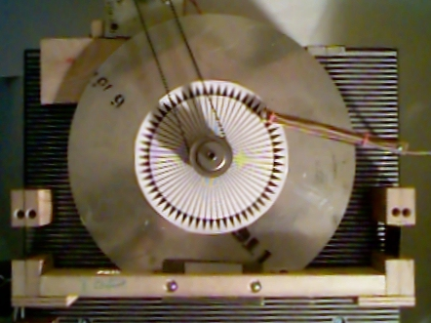

Figure 3. Test fixture (top view)

Test results
The fin brake was run with a variable airgap, with test results shown in Figure 4. The peak magnetic field measured at the centerline of the fin was approximately 0.38 Tesla.
Figure 4. Test results
The test results compare favorably with results based on the approximate electrodynamic theory.

Design of full-scale magnetic brake
Based on these test results, a full-scale brake for a roller coaster was designed. The brake is designed to slow down an 800-kilogram roller coaster car as it enters a station.
Table 1. Full-scale magnetic brake specification
Mass of train | M = 809 kg
Initial velocity | 9.1 m/sec
Final velocity | 2.4 m/sec
Braking length | <30 m
Fin height | 100 mm
Fin length | 600 mm
Fin thickness | T = 9.5 mm
Fin material | 80% IACS copper alloy
Magnets | Grade 35 NdFeB, 51mm×51mm×12.7mm
Magnet pole pitch | p = 150 mm

Simulation results for the velocity and deceleration of the coaster while braking are shown in Figure 5. The resultant brake is 26 meters long, which requires 183 kilograms of magnet material. This brake has been built and test results compare favorably with these predictions based on electrodynamic theory [3].
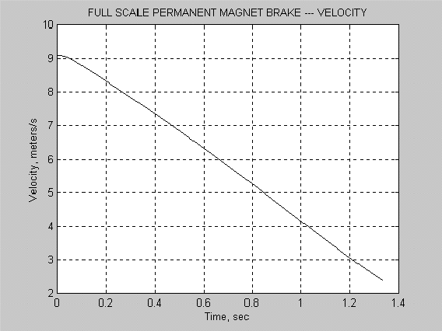  (a) | 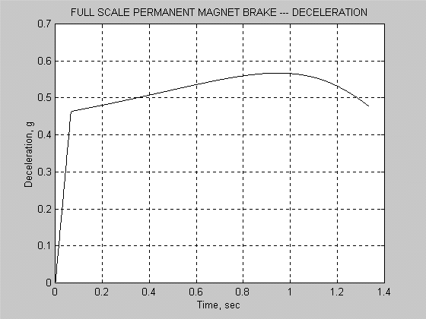  (b)
Figure 5. Prediction for full-scale magnetic brake. (a) Velocity. (b) Deceleration

Conclusions
Permanent magnets are an effective means for achieving low-maintenance braking without the need for external power sources, actuators or controls. Results from Maglev and linear induction motor analyses were used to analyze various PM brakes, with good results between analytic results and test results from a rotating test fixture. It is shown that in PM braking the dominant material cost is for the permanent magnet material. The brakes shown can be used in transportation applications and other applications such as material handling and elevators.

References
- Marc T. Thompson, “High Temperature Superconducting Magnetic Suspension for Maglev,” Ph.D. Dissertation, Department of Electrical Engineering and Computer Science, Massachusetts Institute of Technology, May 1997
- S. W. Lee and R. Menendez, “Forces at low and high-speed limits in magnetic levitation systems,” Journal of Applied Physics, vol. 46, no. 1, Jan. 1975, pp. 422-425
- Magnetar Corporation, private communication with Mr. Ed Pribonic, pribonic@home.com

