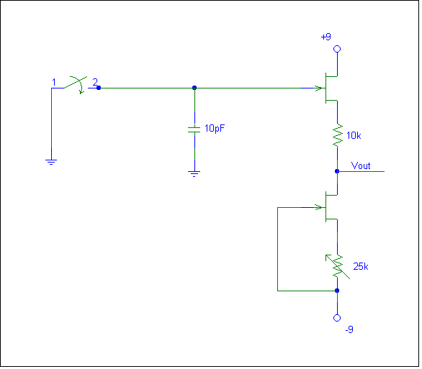

Peter,
My thoughts were to use the follower to measure its own gate leakage current.
(pardon the derivation):

Q=CU
And
d/dT (Q=CU)
is
dQ/dT = C dU/dt + dC/dt U
assuming dC/dt = 0 and recalling that dQ/dt = I
then

I=C dV/dt

I performed the following:
- Closure of input grounding switch and adjustment of current source for zero volts at Vout.
- Installation of a known value capacitor across the gate and opening of the grounding switch.
- Monitoring Vout over time, using starting and ending voltages and times to compute dV/dT. This was done using a storage scope but could just as easily be performed on a multimeter as the rise is very linear.

For my experiment I used PN4118A JFETs , the following data was collected:

C= 10.0 pF (as measured) disc ceramic cap. Measured leakage resistance 360 TΩ
dV/dt = 4.06 mV/s as measured over ~80 seconds
I (calculated) = 40.6 fA

The same JFET’s gate leakage was then measured with a pAmeter. The circuit configuration was as for I_{DSS} with 9 V on the drain. Measured gate leakage was 45 fA.
Several issues could explain the small discrepancy, most likely the leakage of the capacitor insulation and the small amount of hum giving a slightly “fuzzy” scope trace for the dV/dt measurement. Also the slightly larger DS voltage used in the pAmeter measurement will increase gate leakage.
Once the gate leakage is know, the experimenter may substitute in what ever biasing network is to be used. As the gate leakage has been determined and the offset voltage read at Vout, the effective biasing resistance is easily calculated. The technique could be used by those not possessing a pAmeter to selected NPNs with the desired characteristics. I tried a 50 GΩ and 900 GΩ biasing resistor. The calculated resistance using known gate current and offset voltage yielded correct values.

Temperature should be a minor issue it will likely be constant throughout the test.
Also I agree that as the gate voltage rises the gate leakage will decrease slightly but within the limits of this test (<1 volt rise) the slope was constant. Also a higher quality capacitor should be used (plastic film) but I had none in such a small value.

